DATABASES AND KNOWLEDGES ORGANIZATION
group and practical lessons program
- Practical lesson. Environment setup.
  - DBMS MySQL overview.
Before the arrival of MySQL, implementing a database was typically a complex and expensive task involving the purchase, installation, and maintenance of a proprietary database management system from a vendor such as Oracle or IBM. In contrast, MySQL provides a free, open-source database management system that is easy to install, implement, and maintain. In addition, MySQL is fast, extremely reliable, and widely deployed by many companies and organizations worldwide.
It is not an exaggeration to say that MySQL has brought the power of a fully featured, scalable relational database management system to the reach of anyone with a computer and the desire to build a data-driven application or website. MySQL was originally developed by MySQL AB, a company founded in Sweden in 1995, and remained independent until it was acquired by Sun Microsystems in 2008. Oracle purchased Sun Microsystems in 2008 and found itself owning MySQL. Oracle provides a free community and a subscription-based enterprise edition of MySQL. Though the core elements of the two editions are identical, the enterprise edition includes additional scaling, performance, security, backup features, and 24x7 support. To address the broadest possible audience, this book is based on MySQL 9 Community Edition.
The name MySQL comes from a combination of “My” and “SQL.” In this context, “My” is a proper noun rather than a possessive adjective and is named after My, the daughter of Monty Widenius, one of the original developers of MySQL. SQL stands for Structured Query Language; the language used for managing databases.
  - MySQL installation
    - MySQL installation (Windows)
      - Downloading MySQL for Windows
MySQL for Windows is available as a Microsoft Software Installer (.MSI) file. To download the latest Community Edition of MySQL 9, open a web browser and visit the following page: https://dev.mysql.com/downloads/mysql/
On the download page, use the menu at the top to select the latest version of MySQL 9 (marked as A in Figure 3-1). Additionally, set the operating system menu (B) to Microsoft Windows.

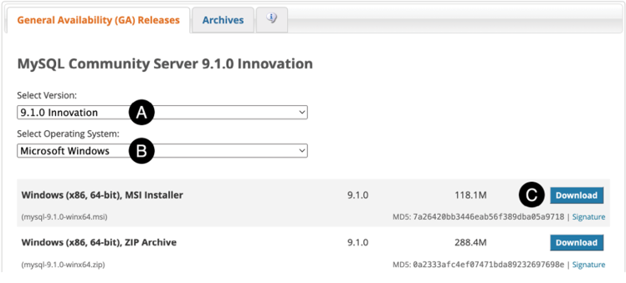
pic 1.1
To download the MSI Installer, click the corresponding Download button (C). When prompted, you can either sign in with your Oracle web account or choose “No thanks, just start my download” to proceed without signing in.

      - Running the software installer
Using Windows Explorer, navigate to where you downloaded the MySQL MSI file and double-click it to begin the installation. Once the installer has loaded, the screen shown in pic 1.2 will appear:

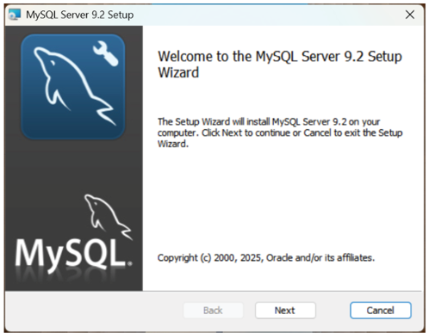
pic 1.2
Click the Next button to review and accept the licensing terms before moving on to the setup type screen shown below:

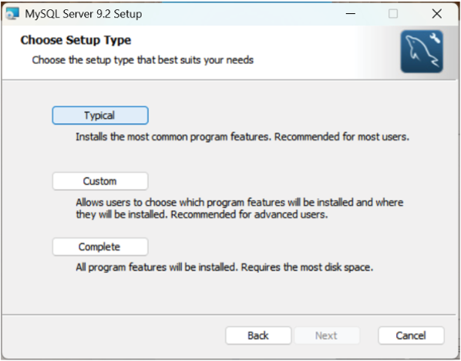
pic 1.3
For the purposes of this book, the “typical” option will provide everything you need to learn MySQL, so select this option to start the installation process.
After completing the MySQL installation, the screen displayed in pic 1.4 will appear. The next step is to configure and start the MySQL Server using the MySQL Configurator tool. Ensure the “Run MySQL Configurator” option is checked, then click the Finish button:

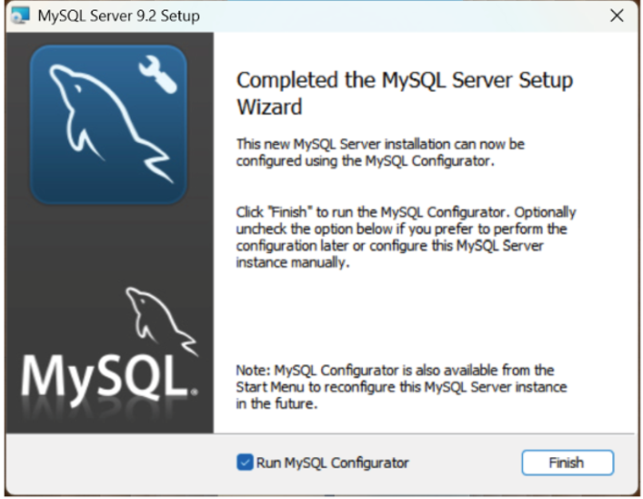
pic 1.2
      - Configuring and starting MySQL Server
The MySQL Configurator tool configures the installation, initializes the database, and starts the server. It can be launched from the Windows start menu anytime to modify configuration settings. When you open the MySQL Configurator for the first time, it will display a welcome screen, as shown in pic 1.3:

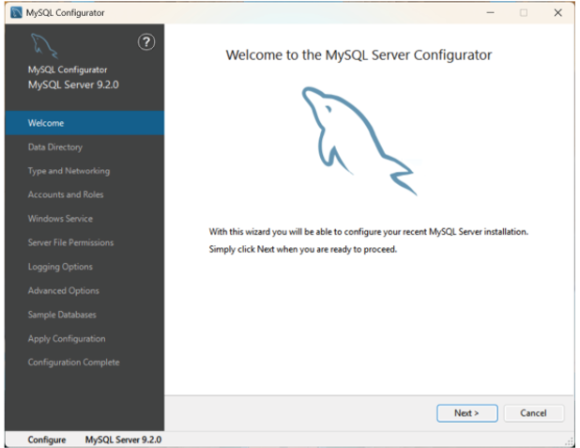
pic 1.3
      - Data directory
Click Next to proceed to the Data Directory screen (pic 1.4). The default location for the database files is as follows, where <version> is replaced by the version of MySQL that was installed:
C:\ProgramData\MySQL Server <version>\
For example, if you installed MySQL 9.2, the data directory will default to the following path:
C:\ProgramData\MySQL Server 9.2\
If you prefer to use a different directory for the database data, click the button labeled ‘...’ to select another location:

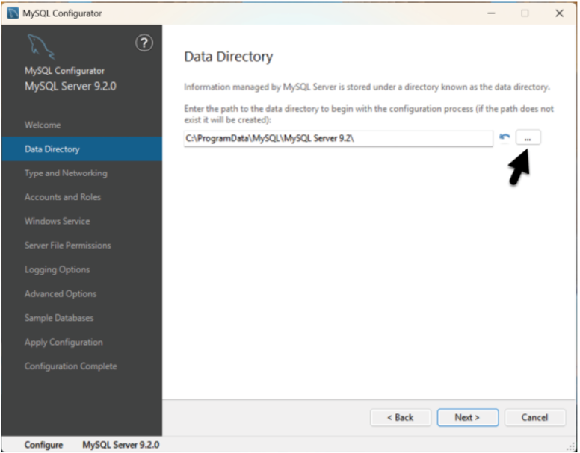
pic 1.4
      - Type and network settings
The next screen contains settings related to the configuration type and network connectivity:
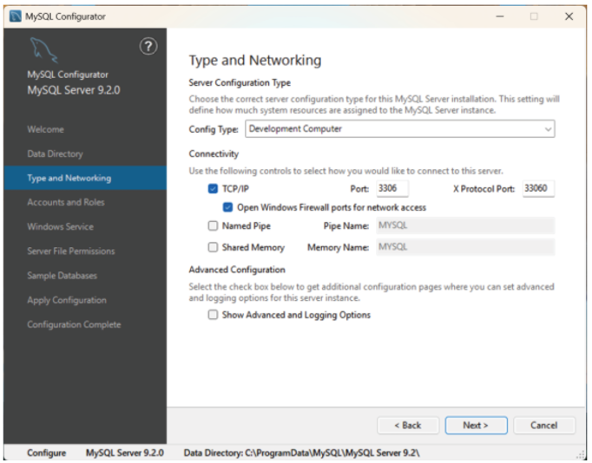
Pic 1.5
The Config Type menu allows you to configure the memory allocated to the MySQL Server during operation. The available types are as follows:
•Development Computer - This setting is intended for situations where MySQL is run on a personal computer during development, and the system is also used for other tasks not related to MySQL. To prevent any negative impact on the performance of other applications on the system, this option configures MySQL to use a minimal amount of memory.
•Server Computer - Choose this option for production servers that will be running additional services alongside MySQL Server, such as web and application servers. This option allocates more memory to MySQL compared to the Development type while maintaining the performance of the other services.
•Dedicated Computer - This configuration is intended for systems that run only MySQL Server, allowing the server to utilize all available system memory.
•Manual - This option prevents the MySQL Configurator from altering the memory allocation. As a result, MySQL will revert to the settings specified in the my.ini file located in the MySQL data directory, which was configured on the previous screen of the configurator.
The network settings manage access to MySQL Server from external sources. For most development installations, these settings typically do not require changes.

      - Accounts and roles
Use the Accounts and Roles screen to set a password for the MySQL root user account. The root account functions as a “superuser,” providing complete access and control over the databases managed by MySQL. For this reason, it is crucial to select a sufficiently complex password. You can also add additional user accounts in this section, though we will discuss this topic further later in the book:
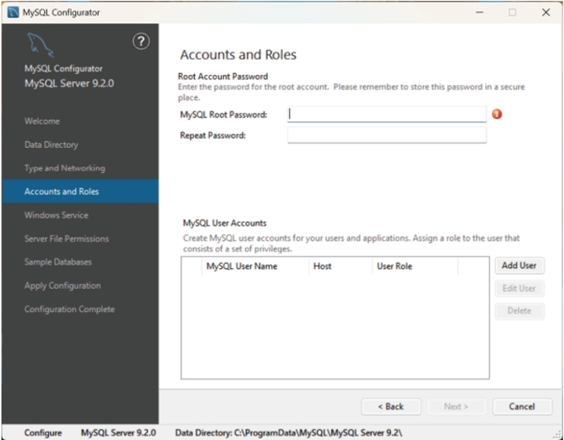
pic 1.6
      - Windows service
The Windows Services screen determines how MySQL Server operates on the system. MySQL can run as a managed Windows service or be launched manually by executing the mysqld.exe file. However, launching the server manually involves additional steps and requires passing several command-line configuration options to mysqld.exe. Using the Windows service option is recommended unless you have a specific requirement that necessitates manual execution.
When the Windows service option is enabled, you can configure MySQL Server to start automatically when the system boots up. By default, the MySQL Windows service runs under the system’s NetworkService user account. However, you can choose to use a different user account. Keep in mind that this account must have the appropriate permissions and access rights on the Windows system. Setting this up requires advanced knowledge of Windows system administration:

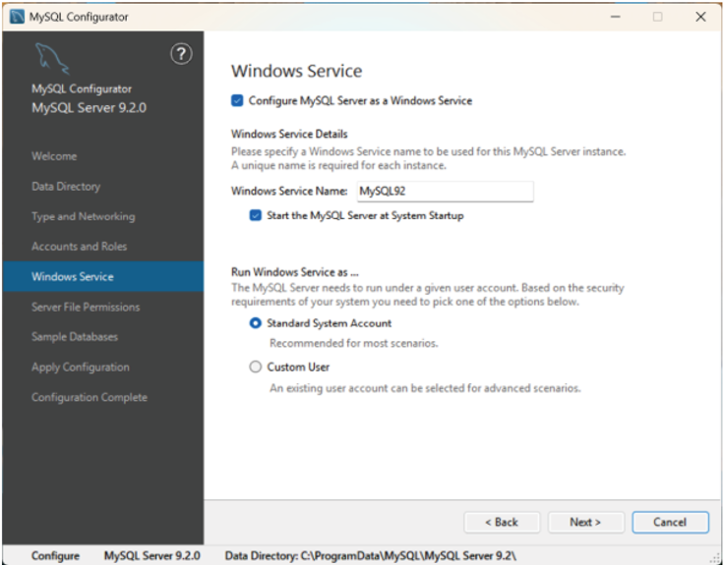
Pic 1.7
      - Server file permissions
The Server File Permissions screen lets you configure access controls for files in the data directory. Generally, it is advisable to grant access to both the current user (likely yourself) and system administrators:
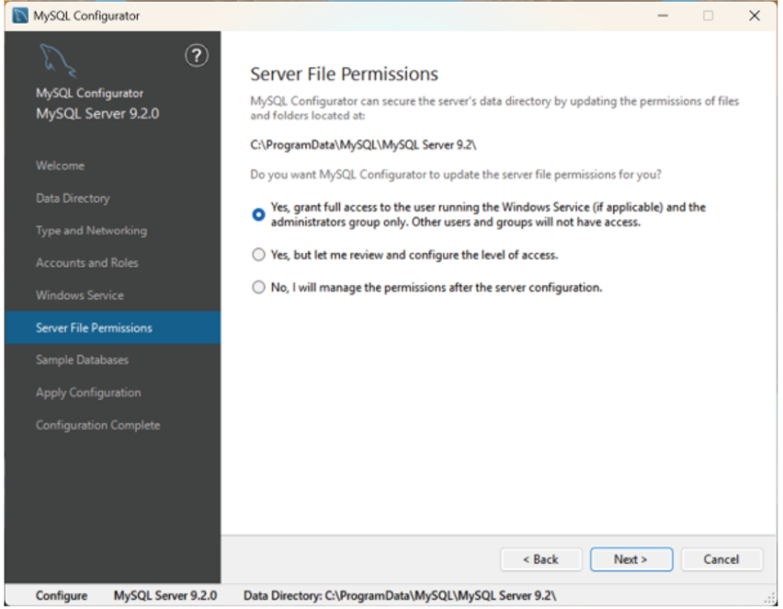
pic 1.8
      - Sample databases
MySQL for Windows includes a collection of sample databases that can be installed for educational purposes. Although these databases will not be utilized in this book, you are welcome to install them on your system.
      - Applying the configuration
Before using MySQL, the final step is to apply the configuration settings and start the server. The screen in pic.1.9 outlines the steps to be performed and will update as each step is completed. To begin the configuration, click the “Execute” button and wait for the process to finish:

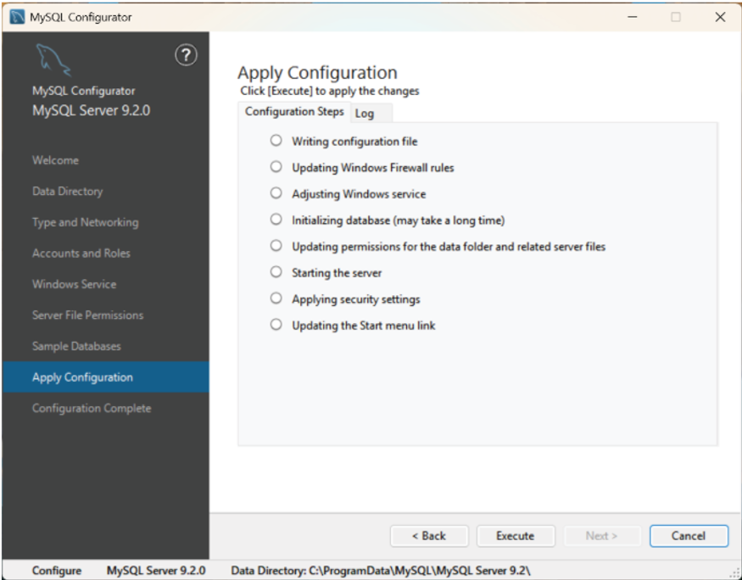 pic. 1.9
If the configuration fails, select the Log tab and review the log information for error details.
      - Setting the PATH environment variable
In addition to the Configurator, MySQL includes several command-line tools for managing and interacting with the MySQL server. To avoid typing a long pathname each time you want to execute a command, it helps to add the path to these tools to your PATH environment variable. Assuming that you installed MySQL into the default location, the following path will need to be added to your PATH environment variable (where <version> is replaced by the version of MySQL that was installed):
C:\Program Files\MySQL\MySQL Server <version>\bin
To ensure this is included in the path whenever a Command Prompt or PowerShell is opened, right-click on the Windows Start menu, select Settings from the resulting menu, and enter “Edit the system environment variables” into the “Find a setting” text field. In the System Properties dialog (pic 1.10), click the Environment Variables... button:
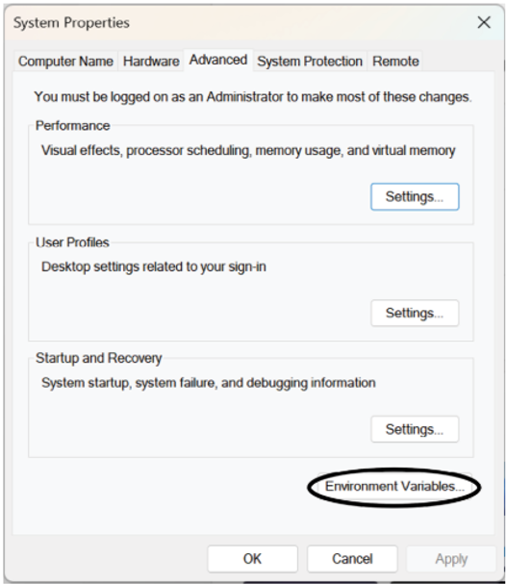
pic 1.10
In the Environment Variables dialog, locate the Path variable in the User variables list, select it, and click the Edit button:
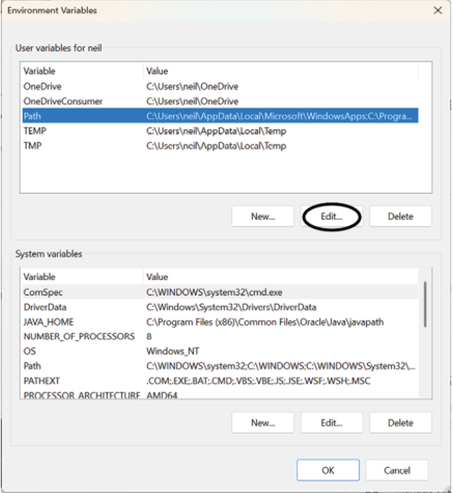
pic. 1.11
Using the New button in the edit dialog (pic 1.12), add a new entry to the path. For example, assuming MySQL was installed into C:\Program Files\MySQL\MySQL Server 9.2\bin\, the following entry would need to be added:
C:\Program Files\MySQL\MySQL Server 9.2\bin\
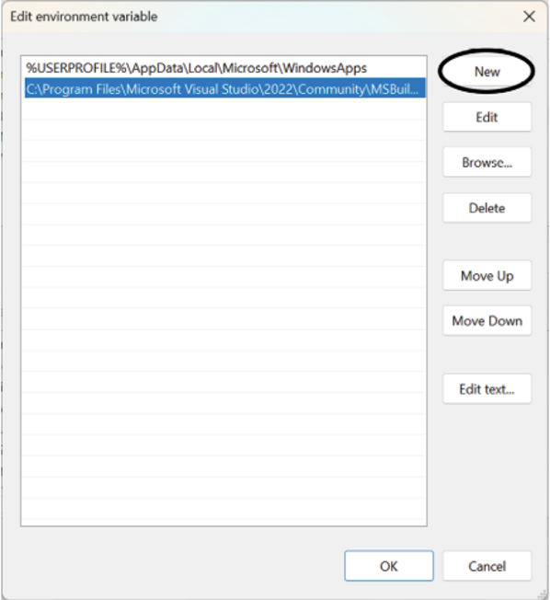
pic. 1.12
Once the new path entry has been added, click OK in each dialog box and close the system properties control panel.
Open a Command Prompt window by pressing Windows + R on the keyboard and entering cmd into the Run dialog. Within the Command Prompt window, enter:
echo %Path%
The returned path variable value should include the MySQL path. Verify that the path is correct by attempting to run the mysql client as follows:
mysql --version
If the Path is correctly configured, you should see output similar to the following:
mysql Ver 9.2.0 for Win64 on x86_64 (MySQL Community Server - GPL)

      - Securing MySQL Server on Windows
Once the installation is complete, an additional step is recommended to increase MySQL’s security. MySQL provides a tool called mysql_secure_installation, which allows us to eliminate potential vulnerabilities. When executed, this command will prompt for the current root password:
C:\Demo> mysql_secure_installation

Securing the MySQL server deployment.

Enter password for user root:
The next option is to install the password validation component. This component ensures that all user passwords are strong and secure. It is recommended to install this component if you are working in a production environment; however, it is not essential if you are simply learning MySQL on a local system.
VALIDATE PASSWORD COMPONENT can be used to test passwords and improve security. It checks the strength of password
and allows the users to set only those passwords which are secure enough. Would you like to setup VALIDATE PASSWORD component?
Press y|Y for Yes, any other key for No:

The tool will then ask if you wish to change the current root password:Using existing password for root.
Change the password for root ? ((Press y|Y for Yes, any other key for No) :

The mysql_secure_installation command will prompt you to remove the anonymous user, disallow remote root access, and delete the test database. Generally, it is recommended to agree to these suggestions. However, if you are accessing your Linux server remotely, such as through a secure shell (SSH) connection, you will need to keep remote root access until you have created at least one additional user account:
Remove anonymous users? (Press y|Y for Yes, any other key for No) : y
Success.

Normally, root should only be allowed to connect from 'localhost'. This ensures that someone cannot guess at the root password from the network. Disallow root login remotely?
(Press y|Y for Yes, any other key for No) : n

By default, MySQL comes with a database named 'test' that anyone can access. This is also intended only for testing, and should be removed before moving into a production environment.
Remove test database and access to it? (Press y|Y for Yes, any other key for No) : y
- Dropping test database...
Success.
- Removing privileges on test database...
Success.
Finally, mysql_secure_installation will request permission to reload the privilege tables to apply the changes. Enter ‘y’ to complete the process of securing the MySQL installation:
Reload privilege tables now? (Press y|Y for Yes, any other key for No) : y
Success.
All done!
      - Launching the mysql client
Now that the MySQL server is running, we need a way to interact with it. The simplest option is to use the MySQL client (mysql). This tool connects to the server and provides a command-line environment for executing SQL statements on the stored data.
When starting the MySQL client, you must provide a username and password to access the server. Since this is a new installation, the only configured user (unless you added more in the MySQL Configurator) is the root user, and you will use the password that you specified during the configuration process. To start the MySQL client, run the following command in a Command Prompt window and enter the root password when prompted:
mysql -u root -p
Once mysql has connected, the following output will appear:
Welcome to the MySQL monitor. Commands end with ; or \g.
Your MySQL connection id is 8
Server version: 9.2.0 MySQL Community Server - GPL

Copyright (c) 2000, 2024, Oracle and/or its affiliates.

Oracle is a registered trademark of Oracle Corporation and/or its
affiliates. Other names may be trademarks of their respective
owners.

Type 'help;' or '\h' for help. Type '\c' to clear the current input statement.
mysql>
At the mysql> prompt, enter the following SQL statement:
mysql> SHOW DATABASES;
+--------------------+
To exit from mysql, enter exit or quit at the prompt:
mysql> quit;
Bye

    - MySQL installation (macOS)
      - Downloading MySQL for macOS
MySQL for macOS is provided as macOS disk image (.dmg) files and is available for Apple Silicon (arm64) and Intel (x86_64) Mac systems. To download the latest MySQL 9 community edition, open a browser window and navigate to the following web page:
https://dev.mysql.com/downloads/mysql/
Use the menu at the top of the download page to select the latest MySQL 9 version (marked A in pic 1.13) and set the operating system (B) and version (C) menus to match your macOS version and processor architecture. Finally, click the Download button (D) next to the DMG Archive list item:

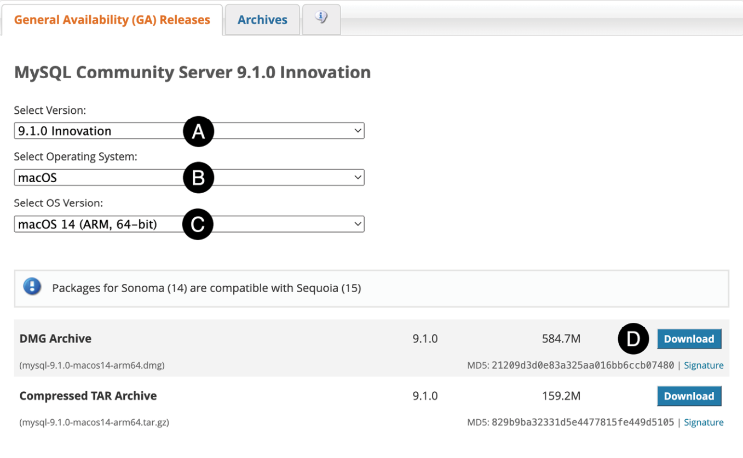
pic 1.13
When prompted, you can either sign in with an Oracle web account or select the “No thanks, just start my download” option to proceed anonymously. Finally, save the disk image to your local filesystem.
      - Running the package installer
To complete the installation, locate the downloaded MySQL disk image file and double-click it to open the image in a Finder window:
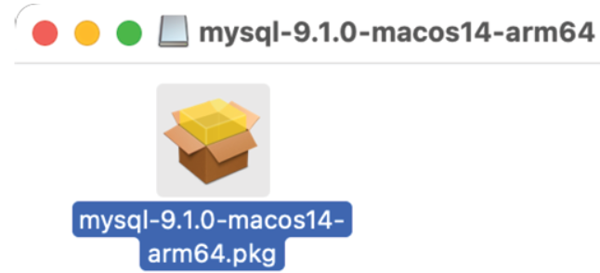
pic 1.14

      - Double-click the .pkg file located within the disk image to launch the MySQL package installer. The installer interface should appear as shown in pic 1.14:
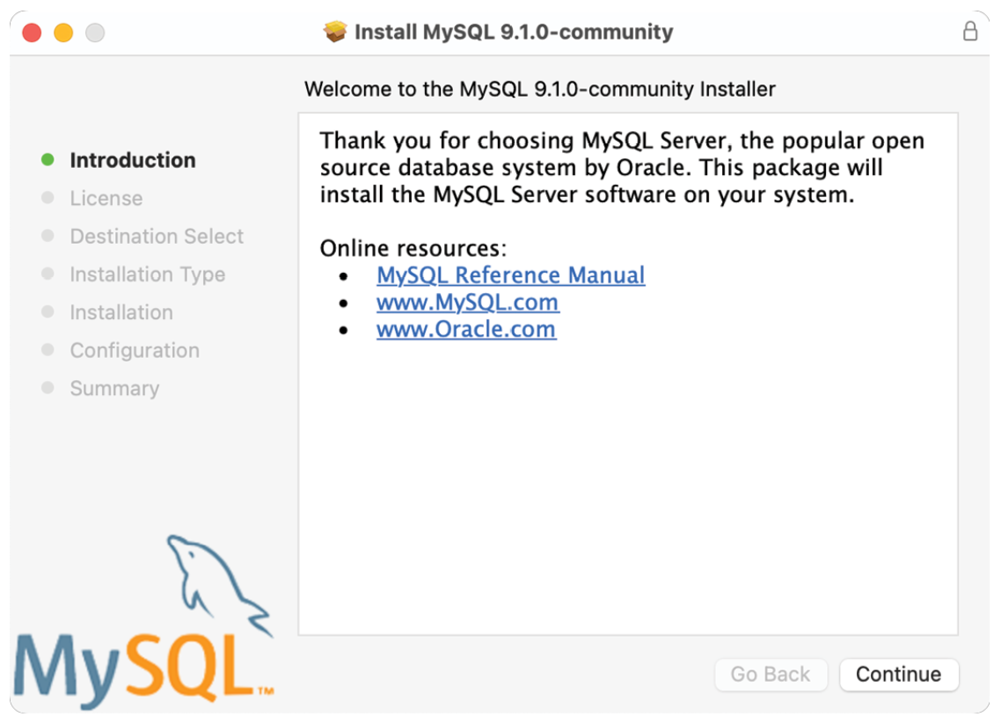
pic. 1.14
      - Click the Continue button on the welcome screen, review and accept the licensing terms, and on the destination selection screen, choose the option to install MySQL for all system users:
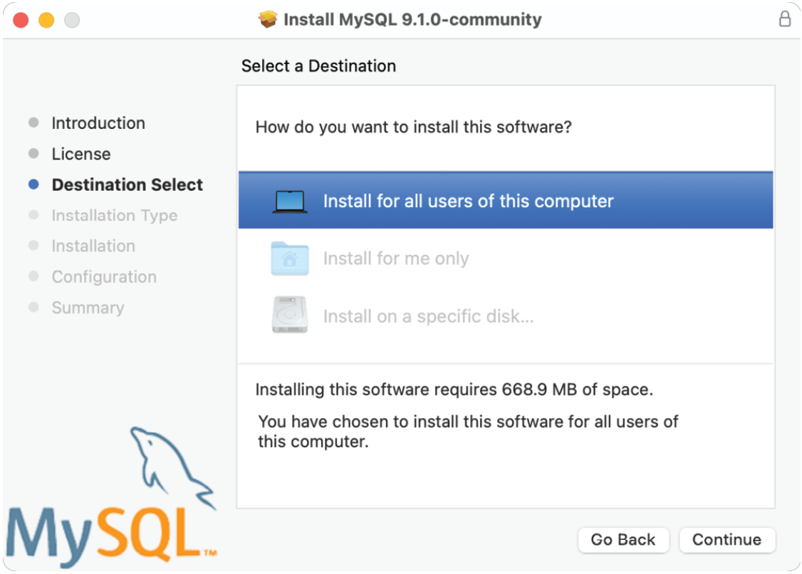
pic. 1.15
      - Click the Continue button to proceed to the installation type screen. By default, MySQL will be installed in the /usr/local/mysql directory, which we will use as the reference point for the remainder of this chapter. If you prefer to install MySQL in a different location, click the “Change Install Location...” button and choose your desired directory.
Remaining in the Installation type screen, click the Customize button, as shown by the arrow in pic. 1.16 below:
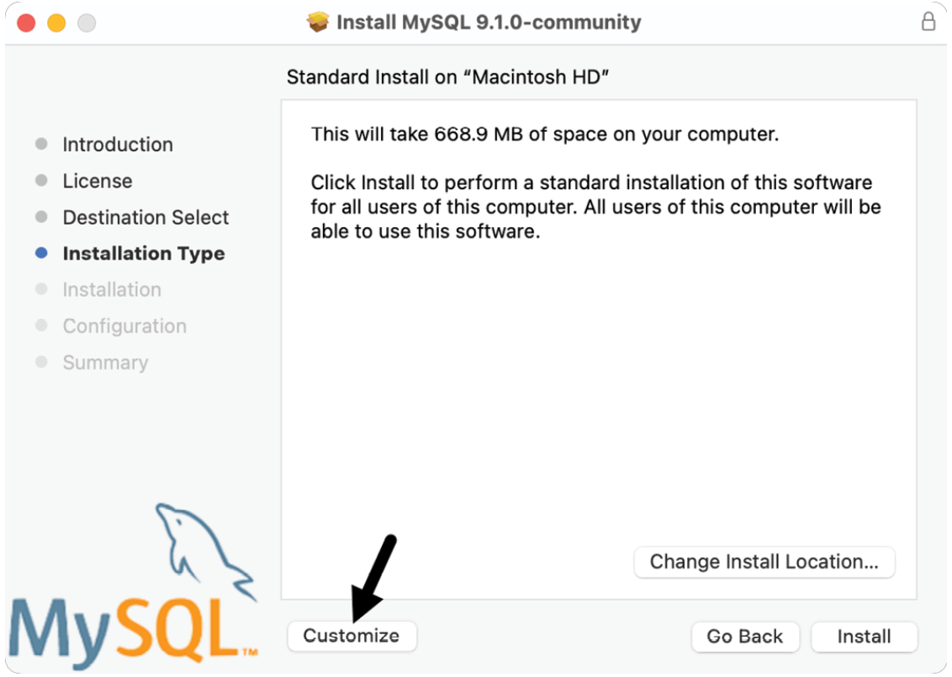
pic 1.16
The customization screen lets you choose which MySQL packages to install on your Mac. Enable the MySQL Server, Preference Pane, and Launchd Support packages. After that, click the Go Back button to return to the installation type screen:
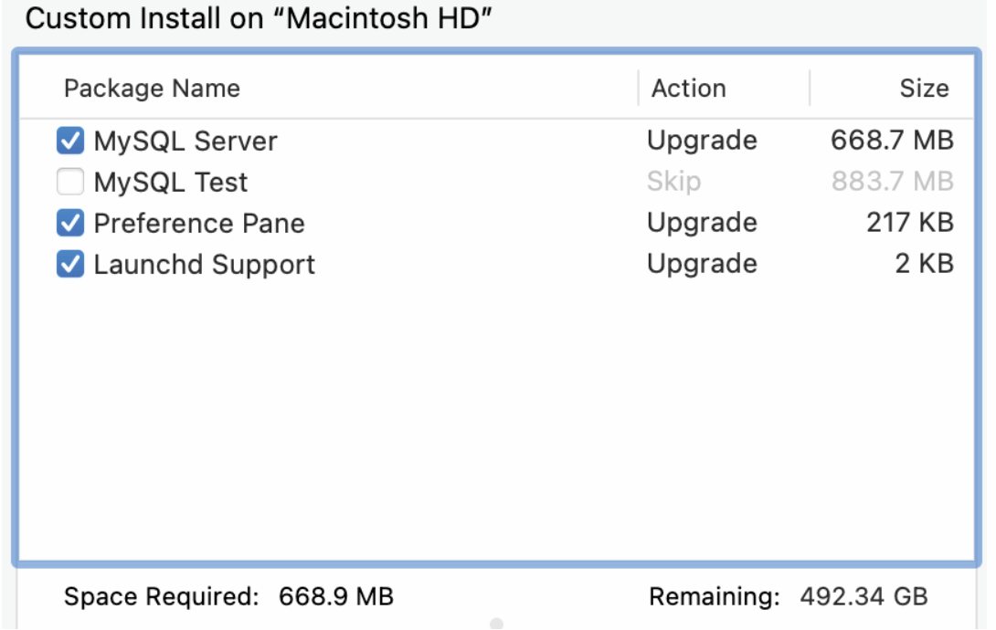
pic. 1.17
After returning to the installation type screen, click the Install button. Once the installation is complete, the package installer will prompt you to enter a password for the root account of your MySQL Server configuration. The root account acts as a “superuser,” granting you unlimited access and control over the databases you create with MySQL. Therefore, it is important to choose a sufficiently complex password.
We will explain how to start and stop the MySQL Server later, so make sure to turn off the “Start MySQL Server after installation” option before clicking Finish:
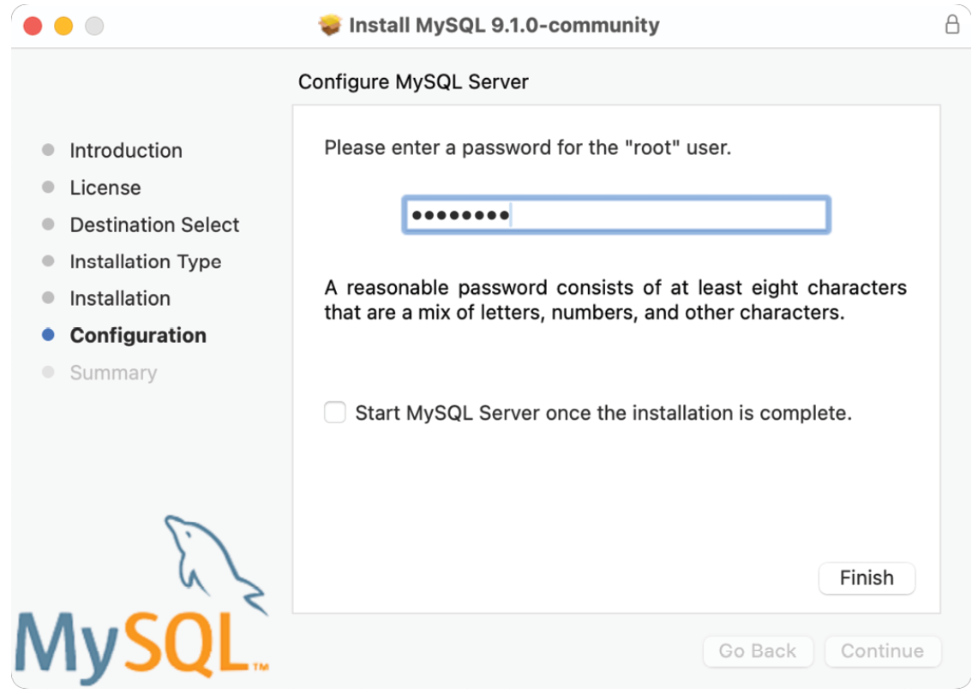
pic 1.18
If prompted, enter your macOS user password, then wait while the installer performs some final database initialization steps. Once these steps are complete, click the Close button to exit the package installer.
      - Using the Preferences Pane
During the installation, we chose to install the Preference Pane. This pane is integrated into the macOS System Settings app and offers a central location for managing and configuring MySQL on your Mac. To access the panel, click on the Apple logo in the top left corner of the desktop toolbar and select “System Settings...” from the menu. In the System Settings app, you can either enter “MySQL” in the search bar or scroll down the left-hand navigation panel until you see the MySQL entry, as illustrated below:
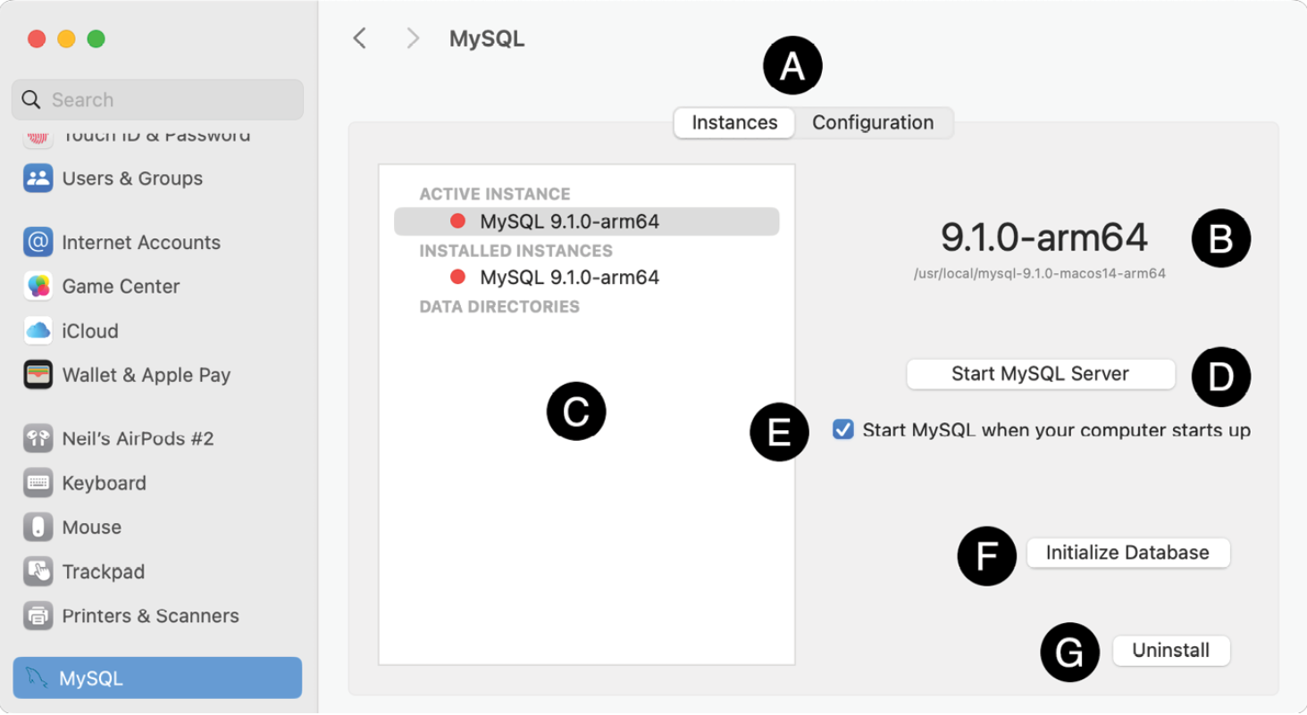
pic 1.19
The tab bar (marked A above) switches between the Instances and Configuration panels.
The Instances pane
The instances panel provides information about the version of MySQL installed (B) and the currently active instances (C). It also lists any custom data directories you have configured on your system, with the default being /usr/local/mysql/data. The button labeled D is used to start and stop MySQL Server instances, while the option to start MySQL automatically when your system boots is indicated by E.
The Initialize Database button (F) creates a new data directory. If the data directory already exists, this action will overwrite any existing data, so it should be used with caution. The Uninstall button (G) will remove MySQL from your system, including data.
To launch the server, click the Start MySQL Server button. Note that the status indicators next to the active and installed instances will change from red to green. You can click the button again to stop the server.
The Configuration pane
The Configuration button in the tab bar, marked as A above, opens the panel shown in pic 1.20. This panel allows you to modify the directories used by MySQL, including the base, data, and plugin directories. You can also change the name and location of the error log and PID files. The PID file is a text file that contains the process ID of the currently running MySQL instance, which is used to determine whether the MySQL server is running on the system.
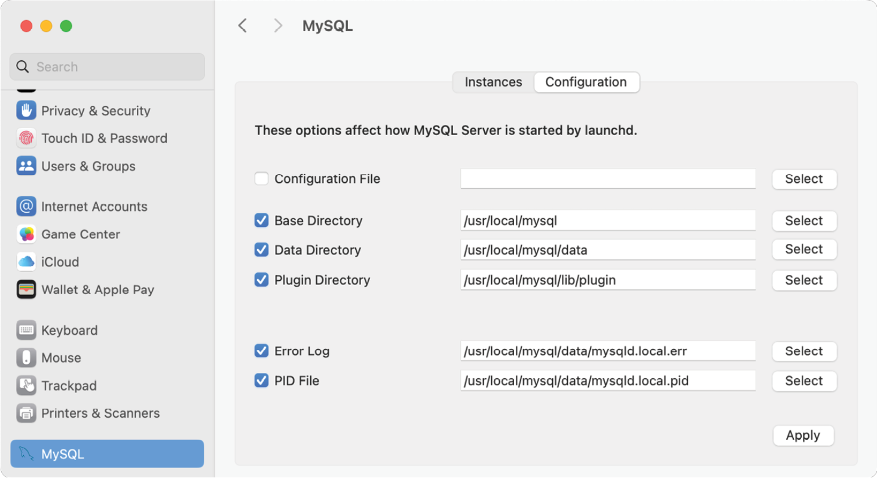
pic 1.20
The configuration pane allows you to specify a custom path for the MySQL configuration file. This XML property list (.plist) file contains the settings for your MySQL installation and is updated in the background by the Preferences Pane as you make changes. Alternatively, you can edit this file directly instead of using the Preferences Pane. The default path for this configuration file is as follows:
/Library/LaunchDaemons/com.oracle.oss.mysql.mysqld.plist
      - Adding MySQL to your PATH
In addition to the Preferences Pane, MySQL includes several command-line tools for managing and interacting with the MySQL server. To avoid typing long pathnames each time you want to execute a command, it helps to add the paths to these tools to your PATH environment variable. Assuming that you installed MySQL into the default location, the following paths will need to be added to your PATH environment variable:
/usr/local/mysql/bin
/usr/local/mysql/support-files
To ensure these are included in the path whenever a new terminal window is opened, an export statement needs to be placed in the zprofile file in your home directory. To add the export statement, open a Terminal window and execute the following command, replacing /usr/local/mysql with your custom path if you specified one during installation:
echo "export PATH=\$PATH:/usr/local/mysql/bin:/usr/local/mysql/support-files" >> $HOME/.zprofile
After adding the path to your shell profile, open a new Terminal window and run the following command:
mysql --version
If your path is configured correctly, you should see output like this:
mysql Ver 9.2.0 for macos14 on arm64 (MySQL Community Server - GPL)
If the shell reports that the mysql command was not found, run the following command to check if the paths were added to the end of the PATH environment variable:
echo $PATH
Next, check the configuration settings in the Preferences pane and verify that the base directory path matches those added to the PATH environment variable.
      - Starting MySQL Server using launch control
MySQL Server can be launched from the command line in several ways, but the recommended method is to use the macOS launch control system. This approach is advantageous because it utilizes the same configuration property list file as the Preferences pane and works regardless of where MySQL is installed on the filesystem.
To start and stop the MySQL server, we use the launchctl command with the load and unload arguments, including the path to the property list file. The launchctl tool requires superuser privileges, so we must use sudo to execute the command.
To start MySQL Server, open a Terminal window and run the following command:
sudo launchctl load -F /Library/LaunchDaemons/com.oracle.oss.mysql.mysqld.plist
When prompted, enter your macOS user password to grant permission to launch the server.
To stop the MySQL Server, use this command:
sudo launchctl unload -F /Library/LaunchDaemons/com.oracle.oss.mysql.mysqld.plist
      - Starting MySQL Server using mysql.server
Alternatively, MySQL Server can be started and stopped using the mysql.server script included in the MySQL support-files directory as follows:
sudo mysql.server start
sudo mysql.server stop
This command does not utilize the configuration settings in the property list file and requires additional steps if MySQL is installed in a location other than /usr/local/mysql. If you installed MySQL in a custom directory, you will need to either navigate to that location before executing the command or specify the base directory path directly on the command line. For example:
sudo mysql.server start --basedir=/my/custom/path/mysql
sudo mysql.server start --basedir=/my/custom/path/mysql
      - Securing MySQL Server on macOS
Once the installation is complete, an additional step is recommended to increase the security of MySQL. MySQL provides a tool called mysql_secure_installation, which allows us to eliminate potential vulnerabilities. When executed, this command will prompt for the current root password:
mysql_secure_installation
Securing the MySQL server deployment.
Enter password for user root:
The next option is to install the password validation component. This component ensures that all user passwords are strong and secure. It is recommended to install this component if you are working in a production environment; however, it is not essential if you are simply learning MySQL on a local system:
VALIDATE PASSWORD COMPONENT can be used to test passwords
and improve security. It checks the strength of password
and allows the users to set only those passwords which are
secure enough. Would you like to setup VALIDATE PASSWORD component?

Press y|Y for Yes, any other key for No:
The tool will then ask if you wish to change the current root password:
Using existing password for root.
Change the password for root ? ((Press y|Y for Yes, any other key for No) :
The mysql_secure_installation command will prompt you to remove the anonymous user, disallow remote root access, and delete the test database. Generally, it is recommended to agree to these suggestions:
Remove anonymous users? (Press y|Y for Yes, any other key for No) : y
Success.
Normally, root should only be allowed to connect from 'localhost'. This ensures that someone cannot guess at the root password from the network.

Disallow root login remotely? (Press y|Y for Yes, any other key for No) : n

By default, MySQL comes with a database named 'test' that anyone can access. This is also intended only for testing, and should be removed before moving into a production environment.

Remove test database and access to it? (Press y|Y for Yes, any other key for No) : y
- Dropping test database...
Success.
- Removing privileges on test database...
Success.
Finally, mysql_secure_installation will request permission to reload the privilege tables to apply the changes. Enter ‘y’ to complete the process of securing the MySQL installation:
Reload privilege tables now? (Press y|Y for Yes, any other key for No) : y
Success.
All done!.
      - Launching the mysql client
Now that the MySQL Server is running, we need a way to interact with it. The simplest option is to use the MySQL client (mysql). This tool connects to the server and provides a command-line environment for executing SQL statements on the stored data.
When starting the MySQL client, you must provide a username and password to access the server. Since this is a new installation, the only configured user is the root user, and you will use the password you specified during the installation process. To start the MySQL client, run the following command in a Terminal window and enter the root password when prompted:
mysql -u root -p
Once mysql has connected, the following output will appear:
Welcome to the MySQL monitor. Commands end with ; or \g.
Your MySQL connection id is 8
Server version: 9.2.0 MySQL Community Server - GPL
Copyright (c) 2000, 2024, Oracle and/or its affiliates.
Oracle is a registered trademark of Oracle Corporation and/or its
affiliates. Other names may be trademarks of their respective
owners.

Type 'help;' or '\h' for help. Type '\c' to clear the current input statement.

mysql>
At the mysql> prompt, enter the following SQL statement:
mysql> SHOW DATABASES;

    - Installing and Launching MySQL on Linux
      - Downloading MySQL for Linux
Most Linux repositories include MySQL packages that can be downloaded and installed using package management tools such as dnf and apt. Additionally, you can configure your Linux system to download and install MySQL directly from the Oracle repositories. However, these options often do not provide access to the latest version of MySQL. For example, as of now, most Linux distributions and the Oracle repositories only offer packages for MySQL 8. To ensure that we install the latest MySQL 9 packages, we will download them directly from the MySQL website and install them manually.
MySQL for Linux is provided as a tar file containing a bundle of package files. Depending on the Linux variant, MySQL is available for Intel (x86_64), AMD (amd64), and ARM (aarch64) systems. To download the latest MySQL 9 community edition, open a browser window and navigate to the following web page:
https://dev.mysql.com/downloads/mysql/
Use the menu at the top of the download page to select the latest MySQL 9 version (marked A in pic 1.21) and set the operating system (B) and version (C) menus to match your Linux distribution and processor architecture. Finally, click the Download button (D) next to the “Bundle” list item:
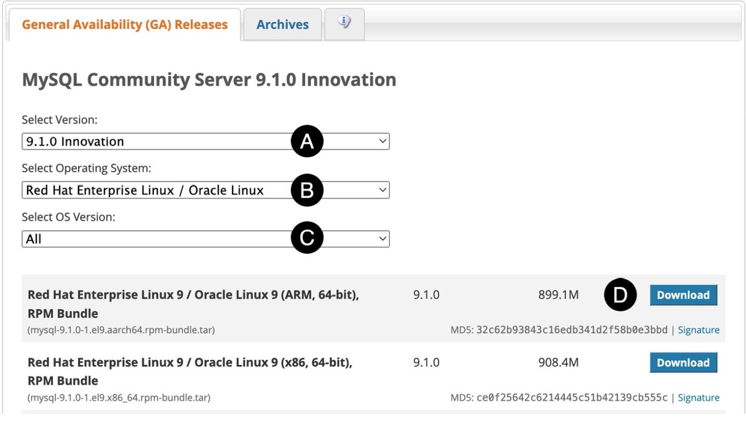
pic 1.21
When prompted, you can either sign in with an Oracle web account or select the “No thanks, just start my download” option to proceed anonymously. Finally, save the image to your local filesystem.
Once the download is complete, open a terminal or shell and extract the packages from the bundle tar file as follows, where <tar-bundle-file-name> is replaced by the name of the file you downloaded:
tar xvf <tar-bundle-file-name>.tar
      - Installing MySQL on RPM-based distributions
MySQL for Red Hat Linux-based systems (including RHEL, Fedora, CentOS, AlmaLinux, and Rocky Linux) is provided as a collection of Red Hat Package Manager (RPM) files named using the following convention:
mysql-community-<component name>-<version>.<os>.<arch>.rpm
For example, the RPM file for the MySQL 9.1.0-1 client for Red Hat Enterprise Linux 9 on ARM-based systems is named as follows:
mysql-community-client-9.1.0-1.el9.aarch64.rpm
From the packages contained in the bundle, we will install the following:
mysql-community-icu-data-files
mysql-community-common
mysql-community-client-plugins
mysql-community-libs
mysql-community-client
mysql-community-server
To complete the installation, change directory to the location of the extracted RPM files, run the following command, and enter your user password when prompted:
sudo rpm -ihv mysql-{community-icu-data-files,community-common,community-client-plugins,community-libs,community-client,community-server}-9*.rpm
After the installation is complete, use the systemctl command to start the MySQL server service as follows:
sudo systemctl start mysqld.service
To check that the service started, run the following command:
sudo systemctl status mysqld.service
If you would like MySQL Server to load each time the system boots, run the following command to change the default configuration:
sudo systemctl enable mysqld.service
To stop the server, use the following systemctl command:
sudo systemctl stop mysqld.service
5.3 Securing MySQL Server on RPM-based systems
Once the installation is complete, the next step is to provide a password for the root account of your MySQL Server configuration. The root account acts as a superuser, granting you unlimited access and control over the databases you create with MySQL. In most cases, MySQL may have applied a
temporary password to the root account during installation. If this is the case, the password will have been logged in the mysqld.log file and can be identified using the following command:
sudo grep "temporary password" /var/log/mysqld.log
If a temporary root password exists, you will see output similar to the following:
2024-11-19T20:02:49.552754Z 6 [Note] [MY-010454] [Server] A temporary password is generated for root@localhost: RDl7E#uvkywM
If no output appears, a password has not yet been applied to the root account. To apply a root password or change the temporary password provided by MySQL, use the mysql_secure_installation tool as follows:
mysql_secure_installation

Securing the MySQL server deployment.

Enter password for user root:
If MySQL has assigned a temporary password, enter it here and input the new password you want to replace it with. If a temporary password was not assigned, enter a password of your choice for the root account.
Once the password has been configured, mysql_secure_installation will ask if you want to remove the anonymous user, disallow remote root access, and delete the test database. In general, you should agree to these suggestions.
Finally, mysql_secure_installation will request permission to reload the privilege tables to apply the changes. Enter ‘y’ to finish securing the MySQL installation.
      - Installing MySQL on Debian and Ubuntu
The bundles for Debian and Ubuntu contain a set of Debian package (.deb) files that can be installed using the Debian package manager (dpkg). From the packages contained in the bundle, we will install the following:
mysql-common
mysql-community-server-core
mysql-community-client-plugins
mysql-community-client-core
mysql-community-client
mysql-client
mysql-community-server
mysql-server
The Debian package files for MySQL use the following naming convention:
<package-name>_<version><os>_<arch>.deb
For example, the package file for the MySQL 9.1.0-1 client for Ubuntu 24.10 on AMD 64-bit systems is named as follows:
mysql-client_9.1.0-1ubuntu24.10_amd64.deb
In addition to the packages mentioned above, MySQL for Ubuntu and Debian require the installation of the libaio1 and libmecab2 library packages.
Therefore, begin by installing these two packages using the following commands and enter your user password when prompted:
On Ubuntu:
sudo apt install libaio1t64 libmecab2
On Debian:
sudo apt install libaio1 libmecab2
To finish the installation, navigate to the directory where the extracted Debian package files are located and execute the following command (note that we are using the wildcard ‘*’ character to avoid typing the version and platform details):
sudo dpkg -i mysql-{common,community-client-plugins,community-client-core,community-client,client,community-server-core,community-server,server}_*.deb
Before the package installation process is complete, a dialog (pic 1.22) will appear requesting the password for the root user account of the MySQL database:

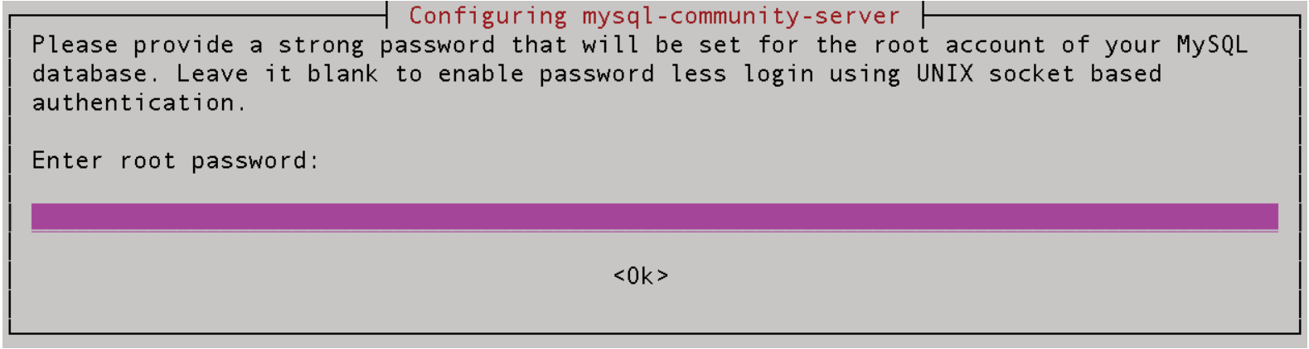
pic 1.21
The root account serves as a super user, providing unrestricted access and control over the databases you create in MySQL. Enter a strong password, then press Enter to close the dialog box and continue with the installation.
Once the installation is complete, use the systemctl command to start the MySQL Server service as follows:
sudo systemctl start mysql.service
To check that the service started, run the following command:
sudo systemctl status mysql.service
If you would like MySQL Server to load each time the system boots, run the following command to change the default configuration:
sudo systemctl enable mysql.service
To stop the server, use the following systemctl command:
sudo systemctl stop mysql.service

      - Securing MySQL Server on Debian and Ubuntu
Once the installation is complete, an additional step is recommended to increase the security of MySQL. MySQL provides a tool called mysql_secure_installation, which allows us to eliminate potential vulnerabilities. When executed, this command will prompt for the current root password:
mysql_secure_installation

Securing the MySQL server deployment.

Enter password for user root:
The next option is to install the password validation component. This component ensures that all user passwords are strong and secure. It is recommended to install this component if you are working in a production environment; however, it is not essential if you are simply learning MySQL on a local system.
VALIDATE PASSWORD COMPONENT can be used to test passwords
and improve security. It checks the strength of password
and allows the users to set only those passwords which are
secure enough. Would you like to setup VALIDATE PASSWORD component?

Press y|Y for Yes, any other key for No:
The tool will then ask if you wish to change the current root password:
Using existing password for root.
Change the password for root ? ((Press y|Y for Yes, any other key for No) :
The mysql_secure_installation command will prompt you to remove the anonymous user, disallow remote root access, and delete the test database. Generally, it is recommended to agree to these suggestions:
Remove anonymous users? (Press y|Y for Yes, any other key for No) : y
Success.

Normally, root should only be allowed to connect from 'localhost'. This ensures that someone cannot guess at the root password from the network.
Disallow root login remotely? (Press y|Y for Yes, any other key for No) : n

By default, MySQL comes with a database named 'test' that anyone can access. This is also intended only for testing, and should be removed before moving into a production environment.
Remove test database and access to it? (Press y|Y for Yes, any other key for No) : y
- Dropping test database...
Success.

- Removing privileges on test database...
Success.

Finally, mysql_secure_installation will request permission to reload the privilege tables to apply the changes. Enter ‘y’ to complete the process of securing the MySQL installation:
Reload privilege tables now? (Press y|Y for Yes, any other key for No) : y
Success.
All done!
      - Launching the mysql client
Now that the MySQL server is secured and running, we need a way to interact with it. The simplest option is to use the MySQL client (mysql). This tool connects to the server and provides a command-line environment for executing SQL statements on the stored data.
When starting the MySQL client, you must provide a username and password to access the server. Since this is a new installation, the only configured user is the root user, and you will use the password that you specified in the previous section. To start the MySQL client, run the following command, and enter the root password when prompted:
mysql -u root -p
Once mysql has connected, the following output will appear:
Welcome to the MySQL monitor. Commands end with ; or \g.
Your MySQL connection id is 8
Server version: 9.1.0 MySQL Community Server - GPL

Copyright (c) 2000, 2024, Oracle and/or its affiliates.
Oracle is a registered trademark of Oracle Corporation and/or its
affiliates. Other names may be trademarks of their respective
owners.

Type 'help;' or '\h' for help. Type '\c' to clear the current input statement.

mysql>
At the mysql> prompt, test the installation by entering the following SQL statement to generate a list of databases:
mysql> SHOW DATABASES;

  - The MySQL Client
In the chapter titled “The Basics of Databases” we learned that MySQL is a client-server-based database management system (DBMS). Along with the MySQL server, MySQL provides an interactive client that allows administrators to connect to server instances and execute SQL statements. In this chapter, we will explore the features of the MySQL client.
The MySQL client is a command-line tool installed with the MySQL package bundle. It can also be installed separately on non-server systems. From the MySQL shell prompt, you can execute various commands on both local and remote database servers. This includes tasks such as creating and deleting databases and tables, searching for data, adding new rows, and much more. There are alternative client tools for interacting with MySQL Server, including MySQL Workbench and phpMyAdmin, which will be discussed in later chapters.
Assuming MySQL has been installed, the mysql tool may be loaded at the operating system command prompt as follows:
mysql -u <username> -p
The -p command-line flag indicates that the account belonging to <username> is password protected, prompting the client to request the password before granting access to the server:
mysql -u root -p
Enter password:

  - Installing MySQL Workbench
    - Downloading MySQL Workbench
MySQL Workbench can be downloaded from the MySQL Developer website at the following URL:
https://dev.mysql.com/downloads/workbench/
Use the menu at the top of the download page to select the operating system (marked A in pic 1.22) and version (B) menus to match your system version and processor architecture. Finally, click the Download button (C) next to the matching installation file:
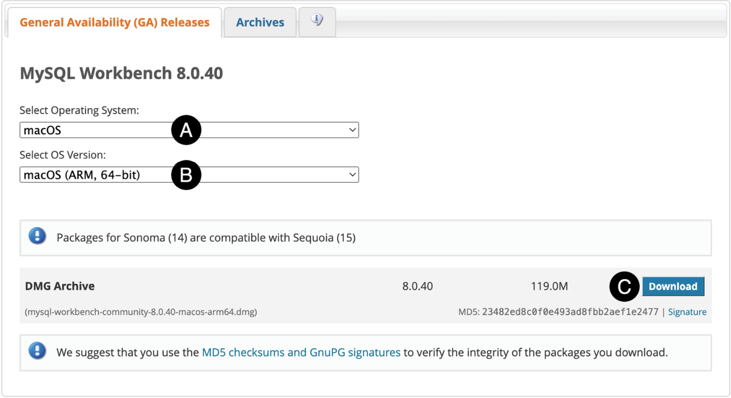
pic 1.22
When prompted, either sign in with an Oracle web account or select the “No thanks, just start my download” option to proceed anonymously. Finally, save the file to your local filesystem. Once the download is complete, follow the instructions below for your operating system.
    - Installation on Windows
MySQL Workbench for Windows is available as a Microsoft Software Installer (.MSI) file. Using Windows Explorer, navigate to where you downloaded the MySQL MSI file and double-click it to begin the installation. Once the installer has loaded, the screen shown in pic 1.23 will appear:
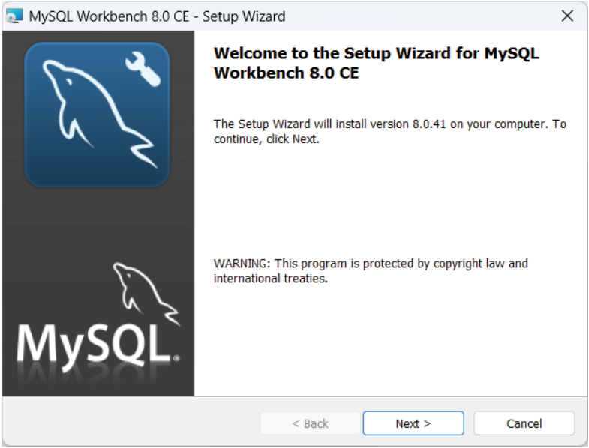
pic 1.23
Click the Next button to review and accept the licensing terms before moving on to the Setup Type screen shown below:
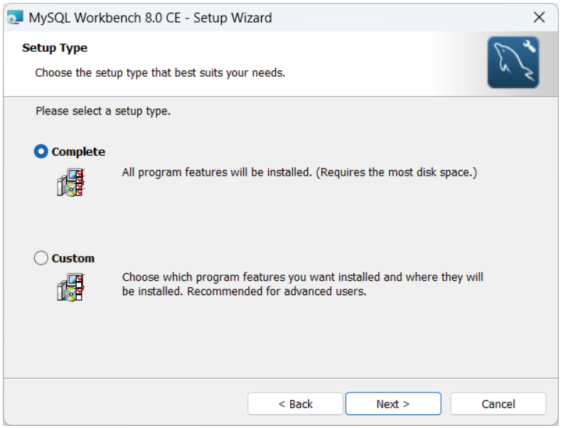
pic 1.24
After completing the installation, the screen displayed in pic 1.25 will appear. Ensure the “Launch MySQL Workbench now” option is checked, then click the Finish button to start Workbench:
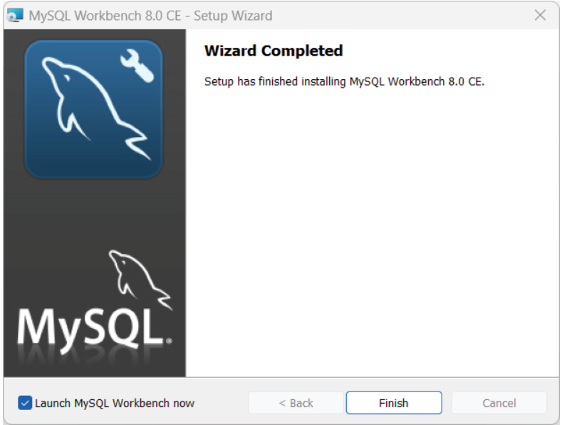
pic 1.25
    - Installation on macOS
To complete the installation on macOS, locate the downloaded disk image (.dmg) file and double-click it to open it in a Finder window:
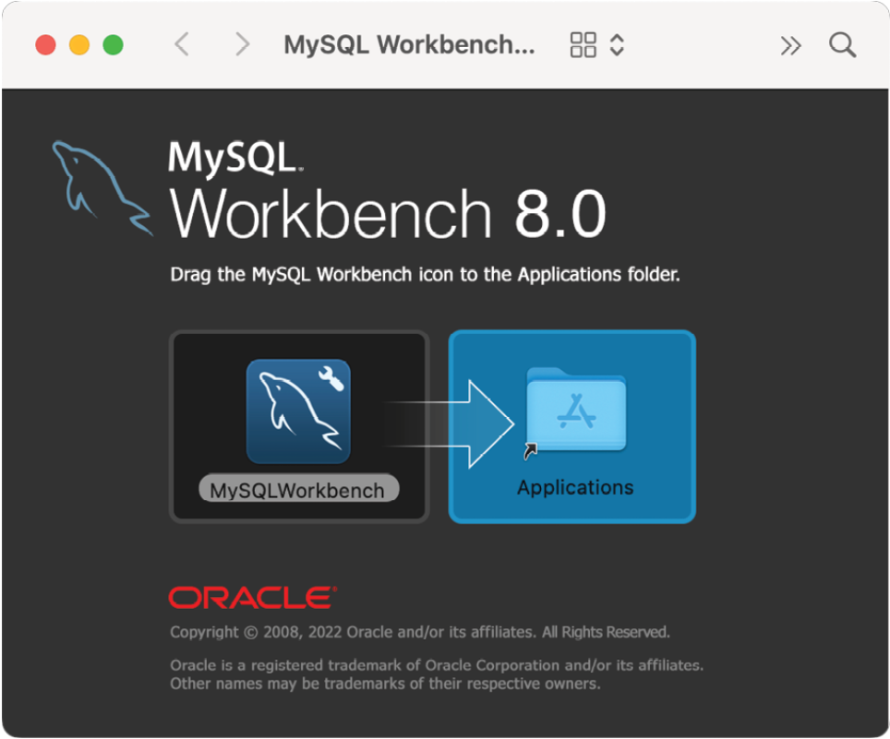
pic 1.26
Within the Finder window, select the MySQL Workbench icon and drag it into the Applications folder. To start Workbench, open the macOS Finder and locate it in the Applications folder. Take this opportunity to drag and drop it onto your dock for easier access in the future. Click on the Workbench icon in the dock to launch the tool.
    - Installation on RPM-based Linux distributions
MySQL Workbench for Red Hat Linux-based systems (including RHEL, Fedora, CentOS, AlmaLinux, and Rocky Linux) is provided as a Red Hat Package Manager (RPM) file named using the following convention:
mysql-workbench-community-<version>.<os>.<arch>.rpm
For example, the RPM file for MySQL Workbench 8.0.40 for Red Hat Enterprise Linux 9 on 64-bit x86 systems is named as follows:
mysql-community-client-9.1.0-1.el9.x86_64.rpm
Before installing MySQL Workbench, we need to install other packages on which it depends. The first steps are enabling the CodeReady Linux Builder (CRB) and installing the Extra Packages for Enterprise Linux (EPEL) repository, which contains several required packages. Open a terminal window and enter the following commands, entering your password when prompted to do so:
crb enable
sudo dnf install \
https://dl.fedoraproject.org/pub/epel/epel-release-latest-9.noarch.rpm \
https://dl.fedoraproject.org/pub/epel/epel-next-release-latest-9.noarch.rpm
Next, use the command below to install the package dependencies:
dnf install libzip unixODBC mesa-libGL-devel gtk2-2.24.33-8.el9proj
To complete the installation, change directory to the location of the downloaded RPM file and run the following command, replacing the <version>, <os>, and <arch> values with those matching your file:
sudo rpm -ihv mysql-workbench-community-8.0.40-1.el9.x86_64.rpm
Once the installation is complete, execute the following command at the shell prompt:
mysql-workbench
Alternatively, MySQL Workbench can be launched from within the desktop environment, for example, within the applications screen of the GNOME desktop.
    - Installation on Ubuntu
At the time of writing, Ubuntu’s latest long-term support (LTS) edition is 24.04, and the current version of MySQL Workbench is 8.0.411. Unfortunately, these two versions are incompatible, so if you are running Ubuntu 24.04 and the latest version of MySQL Workbench is still 8.0.41, you may need to download version 8.0.38 to complete the installation. To download this older version, run the following command in a terminal window:
wget https://cdn.mysql.com/Downloads/MySQLGUITools/mysql-workbench-community_8.0.38-1ubuntu24.04_amd64.deb
To begin the installation, change directory to the folder containing the downloaded package file, replacing <package filename> with the name of the file you downloaded:
sudo dpkg -i <package filename>.deb
During the installation, the installer may report dependency problems like the following:
dpkg: dependency problems prevent configuration of mysql-workbench-community:
mysql-workbench-community depends on libatkmm-1.6-1v5 (>= 2.28.4); however:
Package libatkmm-1.6-1v5 is not installed.
mysql-workbench-community depends on libglibmm-2.4-1t64 (>= 2.66.7); however:
Package libglibmm-2.4-1t64 is not installed.
mysql-workbench-community depends on libgtkmm-3.0-1t64 (>= 3.24.9); however:
Package libgtkmm-3.0-1t64 is not installed.
mysql-workbench-community depends on libmysqlclient21 (>= 8.0.11); however:
Package libmysqlclient21 is not installed.
mysql-workbench-community depends on libodbc2 (>= 2.3.1); however:
Package libodbc2 is not installed.
mysql-workbench-community depends on libproj25 (>= 8.2.0); however:
Package libproj25 is not installed.
mysql-workbench-community depends on libsigc++-2.0-0v5 (>= 2.8.0); however:
Package libsigc++-2.0-0v5 is not installed.
mysql-workbench-community depends on libzip4t64 (>= 0.10); however:
Package libzip4t64 is not installed.
If you see dependency errors, run the following command to resolve them:
sudo apt -f install
Once the installation is complete, execute the following command at the shell prompt:
mysql-workbench
Alternatively, launch MySQL Workbench using the application launcher screen of the GNOME desktop.
  - Visual Studio Code + Draw.io extension installation.
To install VS code go to the appropriate link and follow the instructions:
for Windows - https://code.visualstudio.com/docs/setup/windows,
for Linux - https://code.visualstudio.com/docs/setup/linux,
for Mac - https://code.visualstudio.com/docs/setup/mac.
After VS Code is installed, go to extensions panel and install Draw.io extension.
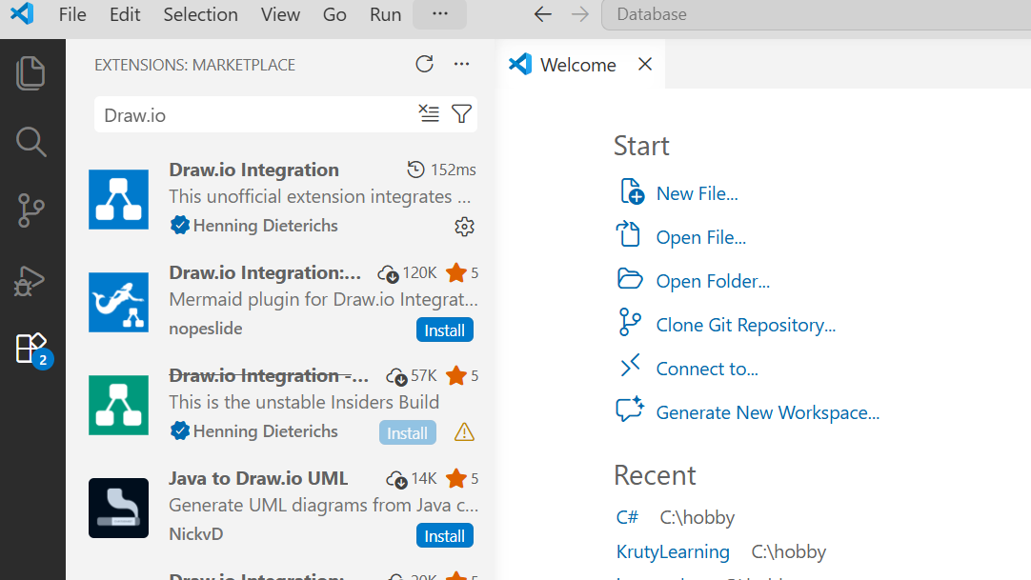
pic 1.27

To start work with schemas go to explorer panel in VS Code a create file with drawio extension.

